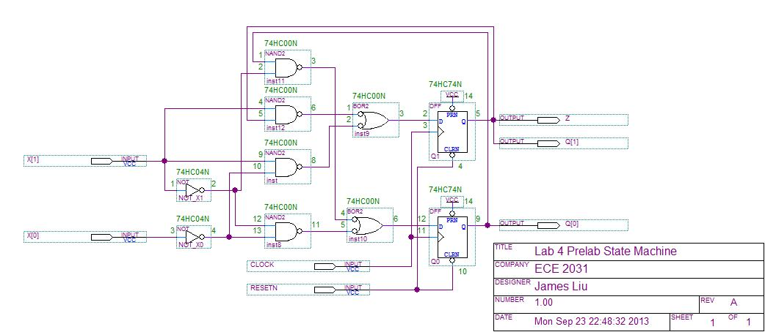

**Figure 1.** Schematic of a 3-state Moore machine with output Z = Q1 with device numbers and pin numbers annotated.



**Figure 2.** Functional simulation waveform diagram of the simulation input vectors that exercises all state transitions of a 3-state Moore machine with output Z = Q1.

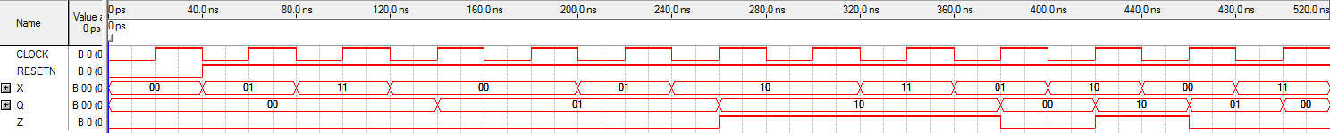

**Figure 3.** Functional simulation waveform of a 3-state Moore state machine compared to a known-good result to verify proper operation. Waveform inputs are set to exercise all state transitions.